10/29/2025 Briana-Yves 1-1 Meeting Minutes

We reviewed the different regions of interest (ROIs) to segment in GBM. A GBM model was initially trained on the BraTS2017 dataset. The dataset includes four protocols: native (T1), post-contrast T1-weighted (T1ce), T2-weighted (T2), and FLAIR. The imaging dataset was segmented into up to four categories with annotations for:
- Necrotic and non-enhancing tumor (label 1)
- Peritumoral edema (label 2)
- enhancing tumor (label 4)
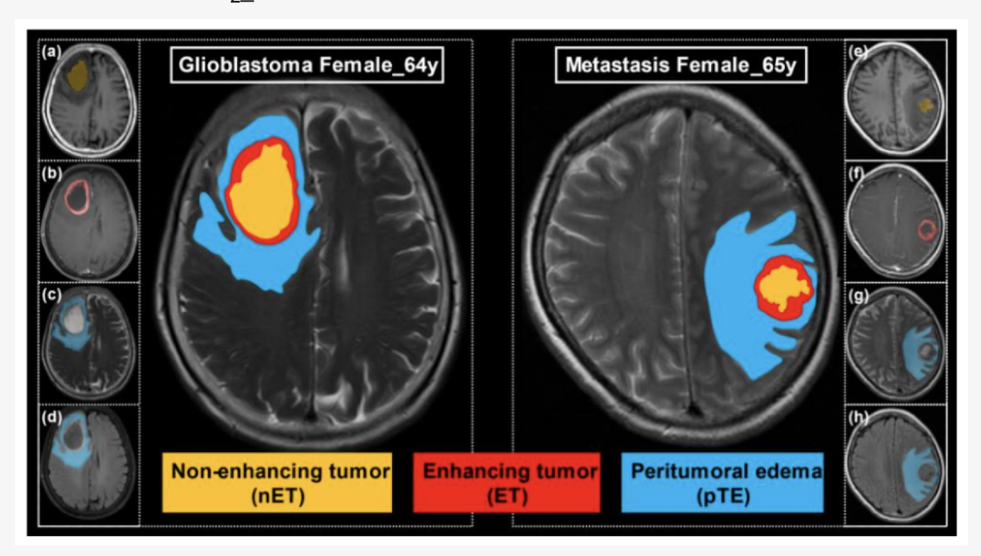
Reference [1]
We decided to train a new GBM model on regions defined as tumor (label 1 and 4) and edema (label 2)
In region-based prediction, unlike standard label prediction, a voxel can belong to multiple regions because the final layer uses independent sigmoid activations rather than a softmax. Each output channel represents a binary region, allowing overlapping memberships (e.g., a voxel can belong simultaneously to the “whole tumor” and “tumor core” regions).
This representation often yields higher Dice and region-level segmentation scores, especially for hierarchical or partially overlapping anatomical structures, since it better reflects their true spatial relationships.
We also discussed improving the abstract titled “Deep Learning Identification of Imaging Biomarkers Predictive of Multifocal Recurrence in Glioblastoma”, which we plan to submit to SNS.
Reference
[1] Wu, J., Liang, F., Wei, R., Lai, S., Lv, X., Luo, S., Wu, Z., Chen, H., Zhang, W., Zeng, X., Ye, X., Wu, Y., Wei, X., Jiang, X., Zhen, X., & Yang, R. (2021). A Multiparametric MR-Based RadioFusionOmics Model with Robust Capabilities of Differentiating Glioblastoma Multiforme from Solitary Brain Metastasis. Cancers, 13(22), 5793. https://doi.org/10.3390/cancers13225793

